Convert Your Tablet Computer into a Document Camera and Stage Stand
Thursday, January 8th, 2015 | Uncategorized
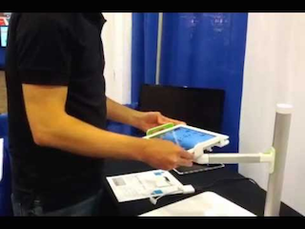
One nifty tool for genealogists is a document camera. You can use one to take a picture of documents, even oversized pieces of paper. It also will take pictures of pages in a book, coins, or any other small object, and much more. If you already own a cell phone or tablet handheld computer, you may already know that its built-in camera can be used to make digital images of papers, maps, books, and more. You may also know that it is no easy feat to take pictures of these items with satisfying clarity. Nonetheless, it can be done—even by an amateur like you or me.
I have used both my cell phone and tablet many times to take close-up pictures of old documents and much more. If the camera has high enough resolution and the light source is good enough, the resultant image can as good as one created by a desktop scanner. For instance, both my cell phone and my tablet computer have 8-megapixel cameras. Similar cameras, or even higher resolution cameras, are available in many of today’s cell phones and tablets. However, for creating detailed images of documents and books, you might want to avoid the lower-resolution cameras found in cheaper or older cell phones and tablets.
As useful as these always-with-you cameras can be, there are a few problems when using a cell phone or tablet to create pictures of documents, pages in a book, and more. “Camera jitter” can cause blurry images. I’ve had some useless, blurry results due to the slightest movement as I snapped the picture. As frustrating as this can be when you’re at home, it can also eat up precious research time when shooting old documents and photos at a library or other repository. You can almost always get better results if you place the camera on a camera stand.
The problem is your heartbeat. It is impossible for a human to hold a camera perfectly still. If your heart is beating (and I certainly hope it is!), there will always be imperceptible movement in your hands. As we age, some of us tend to shake a bit more. It is physically impossible for anyone to hold a camera perfectly still when it is in your hands. You can improve the results by taking a deep breath and holding it, then leaning up against a wall or some other solid object as you snap the picture. However, no handheld camera will ever take a razor-sharp picture that compares with those taken by tripod-mounted or copy-stand mounted cameras.
Did you ever see those gorgeous scenic photographs in Life Magazine or similar, large-format glossy magazines? How many of those do you think were taken by a handheld camera? Perhaps a few, but not many. Most of the super-high-resolution photographs were taken with the camera firmly mounted on a stable tripod or copy stand.
The intent is to produce a photographic image that is razor-sharp, something photographers call “tack sharp.” Even the slightest bit of motion will induce some fuzziness. By having the camera firmly mounted to an immovable tripod or copy stand, you can take tack sharp photographs.
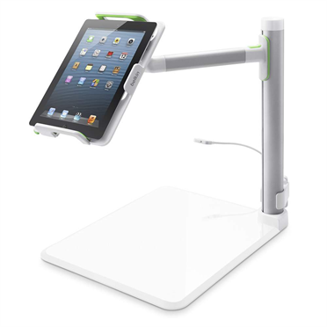
Here is a question: how can you mount a tablet onto a tripod or copy stand? If you have a tablet computer, there is a simple solution. What’s more, the solution also doubles as an interactive whiteboard for use by teachers, lecturers, and others. Do you give presentations at genealogy meetings? Want to do interactive presentations showing the use of a web site or a piece of software? Perhaps you simply need to see your lecture notes when making a presentation.
One solution for the iPad, Galaxy, and Kindle tablet computers can do all that and more. It’s a bit pricey, but if you need such a tool often enough, it just might be worth a little splurge. The tablet solution I am about to describe works better than any cell phone solution I have tried; however, if you are looking for a cell phone solution, I will be describing that in a separate article in the near future.
The Belkin Tablet Stage Stand, along with the included Stage interactive whiteboard and document camera app, lets you transform your tablet computer into a document camera. The stand’s mount suspends your tablet above the “stage” where you place an object or document, so you can focus the camera on the document below. A small, built-in adjustable LED light provides illumination to ensure you get the best picture quality. You can then snap your picture of the item.
Best of all, the Belkin Tablet Stage Stand works with any of the following:
- Galaxy Note
- Galaxy Note 10.1
- Galaxy Note 8.0
- Galaxy Note II
- iPad (Original)
- iPad 2
- iPad 3rd gen
- iPad 4th gen
- iPad mini
- iPad mini 2
- Kindle 3/3G
- Kindle Fire
- Kindle HD Fire 7″
- Kindle HD Fire 8.9″
- Kindle Paperwhite
- Kindle/Kindle Touch
To make sure there is absolutely no camera “jitter,” you can also purchase remote wired or wireless shutter controls from a number of different vendors. Use of a remote shutter means you are not touching the camera at the moment the picture is taken. This helps ensure “tack sharp” images. The device alo has a built in light source to make sure your images are properly illuminated.
Teachers, lecturers, and others who make presentations can also use the Belkin Tablet Stage Stand as a close-up video camera. It can display live video of papers or objects to the audience. You simply connect your tablet to a visual output device, such as a TV or projector, and share the real-time image. In fact, with the proper software installed, you can also connect to the World Wide Web and create webcasts featuring close-up video of the items being presented.
I wish this device was available when I was a high school student in a biology class!
The app included with the Belkin Tablet Stage Stand also lets you overlay text or labels, or highlight key points for a full-featured presentation. It also includes a digital highlighter to help you clearly present your points.
The included app also features the following:
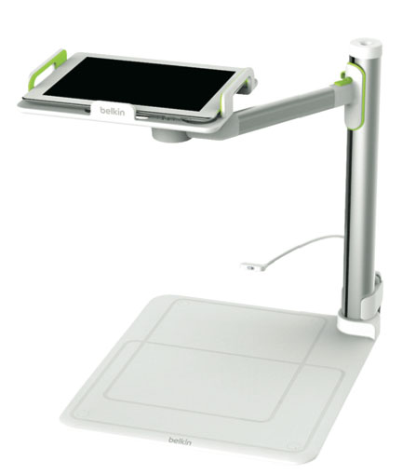
- Sketch, take notes, and add labels over live video
- Record video and audio (feature available as an in-app purchase)
- Save screens with one-click screen snapshot and recall from your photo library in the app
- Dynamically present student work wirelessly using Airplay, or via a wired projector connection
- Store and share labels for later use—great for quizzes or whole-class review
- Annotate, mark-up and save existing photos, images and documents
- Easily switch backgrounds from video to picture to whiteboard/blackboard canvas
- Import PDFs from Dropbox or “Open in…” iOS features (feature available as an in-app purchase)
- Select from multiple pen colors and widths
- Lock/Unlock camera autofocus to produce perfect, blur-free tutorials
- Simple and accessible interface, especially for novice iPad users
The Belkin Tablet Stage Stand is not cheap. It has a list price of $199.99. However, I suspect very few people ever pay list price. I found it on Amazon for $177.49, and I suspect other discount retailers also offer discounts.
I noticed the feedback from prior customers section on Amazon’s sales page for the Belkin Tablet Stage Stand rates it as 4 stars out of a possible 5, based on feedback from 102 customers. Obviously, these are satisfied customers.
The Belkin Tablet Stage Stand is not a tool for everyone. At this price, you will need to use it frequently to obtain a reasonable “return on investment,” or ROI. However, if you will use it enough to justify the cost, you may find the Belkin Tablet Stage Stand to be one of your most valuable tools.
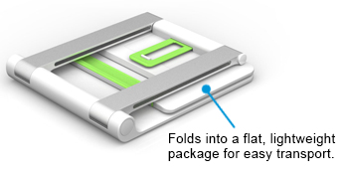
You can learn more about the Belkin Tablet Stage Stand on Belkin’s web site athttp://www.belkin.com/us/p/P-B2B054/. You can also purchase the device from that page for $199.99. Again, I found the same thing selling for $177.49 on Amazon at http://goo.gl/msnzbZ.

6 Comments to '(+) Convert Your Tablet Computer into a Document Camera and Stage Stand'
Gil Bardige
January 8, 2015
When would you use this versus a scanner other than for oversized docs?
Tom Montgomery
January 8, 2015
How high does this adjust? Can it be used for the huge 18″ X 24” ledgers/record books found in most Courthouses?
dickeastman
January 8, 2015
—> When would you use this versus a scanner other than for oversized docs?
Yes. It is a multipurpose tool. Obviously, it will work with normal-sized books but it also works for taking pictures of smaller objects, such as coins, stamps, model. jewelry, and much more. Depending upon your needs, it can be useful for many things.
dickeastman
January 8, 2015
—> How high does this adjust?
The only specification I can find is that the overall unit is 16.4 inches tall. Looking at the pictures, I suspect the tablet probably can sit as high as 15 or 16 inches above the scanning table. However, you could always place the document on the floor and put the Belkin Tablet Stage Stand near the edge of a table. If you did that, you can probably scan documents and maps of several feet long and several feet wide.
Louise Rosett
January 9, 2015
How about something similar for a cell phone/camera?
dickeastman
January 9, 2015
—>: How about something similar for a cell phone/camera?
I can only repeat what I wrote above: ” The tablet solution I am about to describe works better than any cell phone solution I have tried; however, if you are looking for a cell phone solution, I will be describing that in a separate article in the near future.”

