1How to Virtually Drive the Roads Your Ancestors Traveled

Google is a wonderful online tool with many uses, including genealogy. Most genealogists already know that using the online search giant allows us to find records that would be difficult to locate otherwise. However, are you also aware that Google offers other services that allow you to find the location(s) of your ancestor's land and even to virtually travel to that place, all without leaving home?
One of my close friends did just that recently. She was able to locate a deed selling land to Silvanus Clark of Haddam, Connecticut, in 1787. The location of the land was described in the deed, but a description alone is not as satisfying as seeing the land yourself. Of course, travel to Connecticut is difficult for anyone who lives many miles away. A variation of the old phrase, "a picture is worth a thousand words," allows the genealogist to see pictures, maps, and more, thanks to Google. Nothing beats an in-person visit, but Google allows for the next best thing.
I'll retrace my friend's steps as she followed her ancestor's steps online.
NOTE: Click on any of the images in this article to view larger versions.
Here are two images of the original deed, dated Nov. 16, 1787:
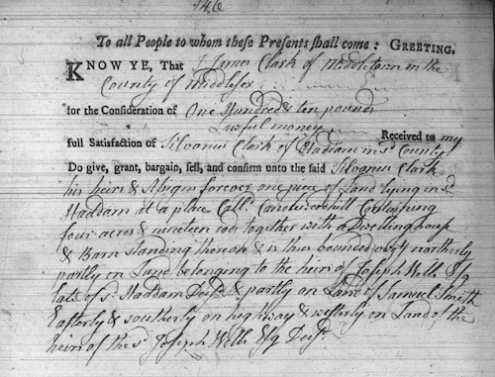
The original deed also contains the signature of the seller:
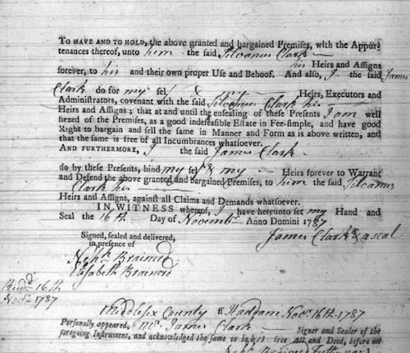
This is great information, but where is Candlewood Hill, as described in the above deed?
A search of Google Maps for Candlewood Hill in Haddam, Connecticut, produces the map shown below. Of course, you can use the controls in the lower right of the window to zoom in and out. You can also hold down the left mouse button to drag the map up, down, left, or right.
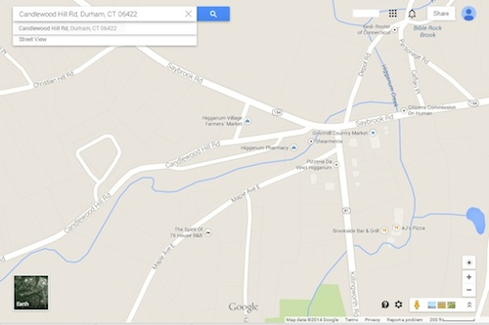
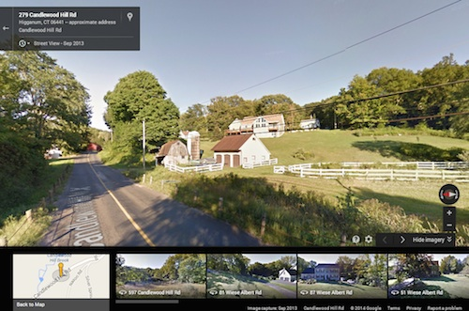
Notice the “Street View” option in the upper left of the above image. Clicking on that produces the following:

The Street View shows images that let the viewer virtually "drive" the road as it is today. You can see the name of the road overlaid on the pavement, and an arrow shows the direction you're moving.
NOTE: The words "Candlewood Hill Road" are not actually painted on the pavement. You can thank Google's "magic" for that. Of course, the road wasn't paved back in 1787, either. You can thank the local town government for that modern-day improvement.
With a mouseclick you can “drive” further down the road, repeating until you reach the desired location, such as the site of a house, an intersection, or the village square. Here again, you can hold down the mouse button and drag the image left and right to see what's on the sides of the road. There is also a small compass in the lower right that rotates the view for you, which may be the easier method of turning if you want to reverse your “driving” direction.
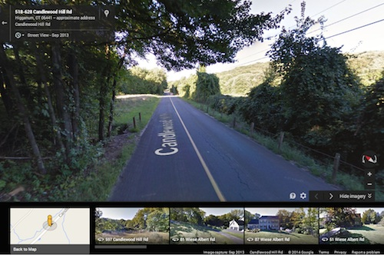
Images appearing at the bottom of the window show your other recent views. The image of the map may be helpful as you “drive” along to track your location. However, you can also click on the Hide Imagery button to clear these pictures from the active area of the screen.

For this trip, we can follow the road along, peering from side to side at the landscape, until the road ends at the intersection with Saybrook Road and the village of Higganum. At this point, my friend reversed direction to see how her ancestors may have proceeded home from trips into this town or to the homes of other Clark family members on the nearby road that would later become Clark Road in Haddam.
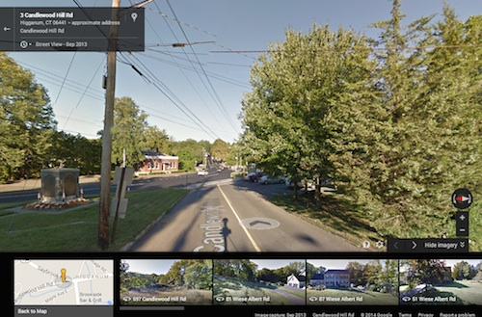
Having satisfied the desire to follow in an ancestors' footsteps or wagon wheels, the other view available is a true bird's eye view. I must say that this view can be pretty spectacular. For this, you need to return to Map view.
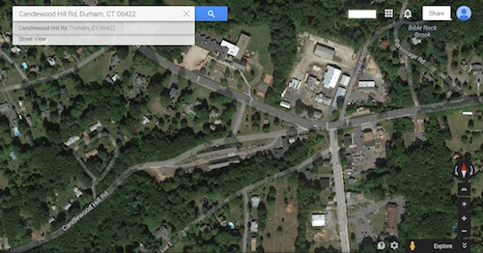
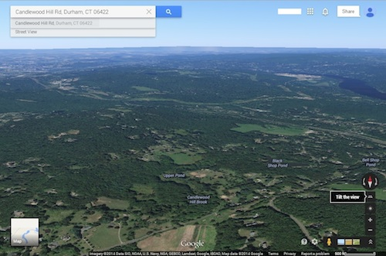
From this view, there's a small image in lower left that lets you switch to Google Earth view (and from Earth view back to the Map view). As with the other views, you can drag the cursor to view different directions; however, these images are so large that they can take longer to fully appear. Once again, you may enjoy using the controls in the lower right, especially the “Tilt” option, which gives a wider view of the area, off to the horizon.

We can also rotate this view to see modern views of the ancestral towns of Haddam and Higganum:
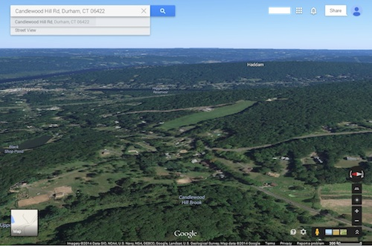
Use of Google's many services allows the genealogist to experience the next best thing to being there in person.
Have you walked in your ancestor's footsteps? Do you have comments, questions, or corrections to this article? If so, please post your words at the end of this article where everyone can benefit from your words. You might also want to read comments posted by others there.

