**BACKGROUND**

The photograph is of the Johann Heinrich Hermann Lahrmann and Maria Bernadine Backhaus family taken between 1910 to 1912. The boy standing on the far left is Franz Gerhard Lahrmann (Frank Henry Lahrman’s father). This photograph and information below the photograph is from Heinrich Lahrmann and Heinrich Middendorf.

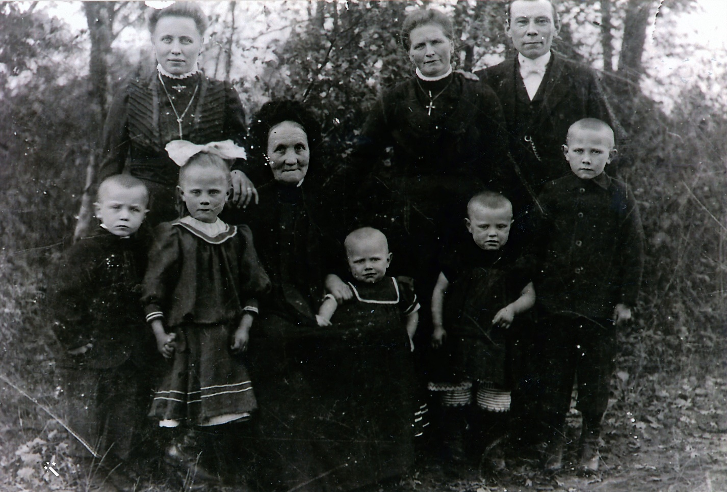

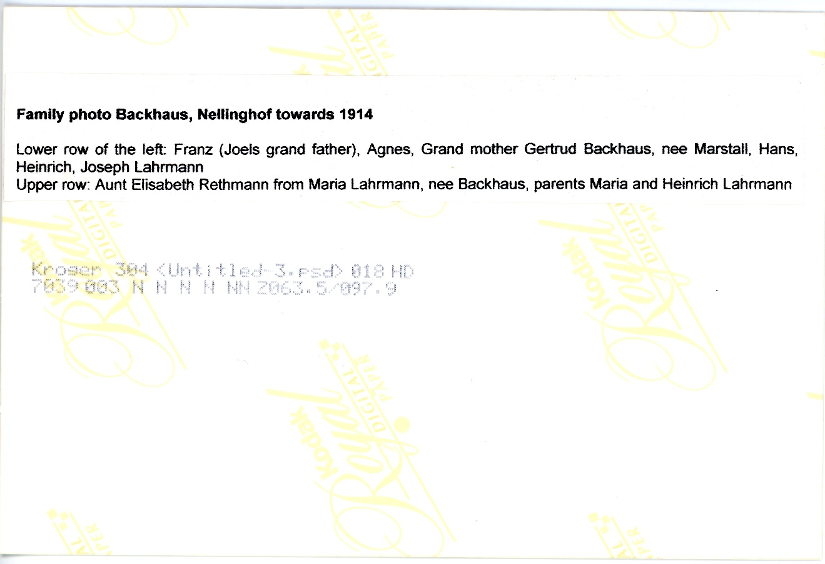

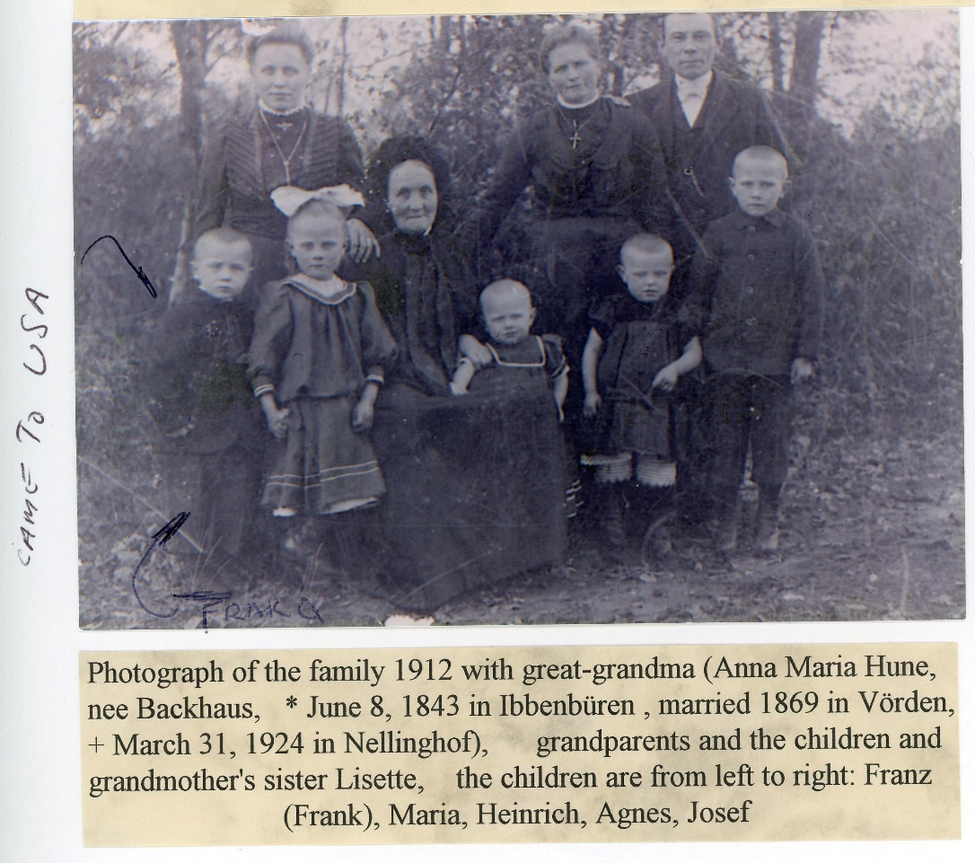

We are looking for information on the lady standing on the far left. She is either Maria Elisabeth Rethamnn geb Backhaus (geb 3 Dec 1874) **or** Maria Lisette Backhaus (geb 15 May 1882) and is the sister of Maria Bernadine Backhaus (geb 4 July 1872). Maria Lisette Backhaus is most likely the correct one. Maria Lisette Backhaus supposedly married Johann Heinrich Rethmann based upon information in the two notes above. Not sure where his first and middle name were obtained. This may not be correct, however the last name should be correct.

**OBJECTIVE**

The objective is to find a marriage record Maria Lisette Backhaus and a Rethmann

**INITIAL SEARCHES**

Some initial searches have been completed as follows:

23 November 2024 – Johann Heinrich Rethmann

Search for the birth record for Johann Heinrich Rethmann (husband to Maria Lisette Backhaus and she is in one of our family photographs). Found people in St. Viktor in Damme Germany. Rathmann is a rare name and so far, only found in St. Viktor’s Church. His parents are Johann Heinrich Rethmann and Maria Agnes Ronnebaum. The following was found:

Marriage

Johan Heinrich Rethmann and Maria Agnes Ronnebaum were married 22 Nov 1870

1. <https://data.matricula-online.eu/en/deutschland/vechta/damme-st-viktor/KB18/?pg=95>
2. Johann Heirnich was born Steinfeld on 28 July 1837
   1. He change his name somehow to Rethmann. Why?
3. Maria Agnes Ronnebaum was born 31 Oct 1839

Their Children’s Births

1. Maria Agnes Rethmann born 5 Nov 1871
   1. <https://data.matricula-online.eu/en/deutschland/vechta/damme-st-viktor/KB17/?pg=234>
2. Catharina Wilhelmine and Bernard Heinrich Rethmann born 7 June 1874
   1. Bernard died 12 Jun 1874
   2. <https://data.matricula-online.eu/en/deutschland/vechta/damme-st-viktor/KB20/?pg=17>
3. Bernhard Heinrich Rethmann 20 Nov 1878
   1. <https://data.matricula-online.eu/en/deutschland/vechta/damme-st-viktor/KB20/?pg=74>

Marriage

Joh. Heinrich Rethmann and Magdalene von Schneider 14 Aug 1865

1. Marriage date is recorded in Carl August Rethmanns birth record

Their Children’s Births

1. Carl August Rethamnn 9 Apr 1870
2. <https://data.matricula-online.eu/en/deutschland/vechta/damme-st-viktor/KB17/?pg=224>

24 November 2024 – Rethmann – Backhaus Marriage

Maria Lisette is the sister to Maria Bernadina Backhaus. Tried to locate the marriage for Johann Heinrich Rethmann and Maria Lisette Backhaus. Have reviewed the marriage records in both St Viktor in Damme and in St. Bonifatius in Neuenkirchen from 1900 through 1920 and have not found their marriage record. (may need to look for a Rethmann Backhous marriage)

26 November 2024 – Rethmann, Johann Heinrich Search

Searched for information on Johann Heinrich Rethmann on Ancestry.com was conducted by selecting the “Search on Ancestry” button under his name in the family tree. The search provided the following information;

<https://www.ancestry.com/search/?name=Johann+Heinrich_Rethmann&gender=m&searchMode=advanced&searchType=t&spouse=Maria+Lisette_Backhaus&treePerson=180047141_152343137906>

The first name of Johann-Heinrich Rethmann shows first and that he was born in Bokern, Vechta. A search for churches in Bokern was conducted on Matricula Online and 4 were found St. Landolinus in Boke, St. Viktor in Damme, St. Gertrud in Lohne, and St Bartholomäus in Schwagstorf-Fürstenau

St Landolinus was ignored since it is fairly far south of Osnabrück and Neuenkirchen.

St Gertrud in Lohne was selected next to search for records. A search for the marriage record for Rethmann, Johan Heinrich and Backhaus, Maria Lisette in St. Gertrude from 1900 to 1920 did not reveal a marriage record for them in this church.

The birth records at St. Gertrud’s were searched in the 1880 time frame. A birth record was found for Maria Catharina Rethmann born to Heinrich Rethamnn and Maria Catharina Bramlage from Bokern on 31 May 1884. The record also has Maria Catharina Pohlmann and Heribert Daniel Rethmann as her god parents. Her birth record is here.

<https://data.matricula-online.eu/en/deutschland/vechta/lohne-st-gertrud/KB11/?pg=183>

27 November 2024 – Rethmann-Braumlage Marriage Record

The Marriage record for Heinrich Rethamnn geb 14 Dec 1850 and Maria Catharina Bramlage geb 9 Mar 1858 was found in St Gertrude in Lohne. They were married on 4 July 1882 and Joseph Rethmann a witness to the marriage.

Heinrich Rethamnn geb 14 Dec 1850 parents are Heribert Daniel Rethmann and Friedrica Agnes Evers. Maria Catharina Bramlage geb 9 Mar 1858 parents are Gerd Bramlage and Catharina Pohlmann. (note that the

<https://data.matricula-online.eu/en/deutschland/vechta/lohne-st-gertrud/KB12/?pg=75>

27 November 2024 – Rethmann - Backhaus Marriage

A search in St. Viktor in Damme marriage records from 1900 to 1910 again show no marriage record for Johann Heinrich Rethmann and Maria Lisette Backhaus

27 November 2024 – Rethmann - Backhaus Marriage

A search in St. Bartholomäus in Schwagstorf-Fürstenau marriage records from 1900 to 1920 again show no marriage record for Johann Heinrich Rethmann and Maria Lisette Backhaus.

27 November 2024 – Rethmann, Joseph Birth Record

Found a birth record for Joseph Rethmann born 29 Apr 1886 to Heinrich Rethamnn and Maria Catharina Bramlage. God parents are Joseph Rethmann and Maria Elisabeth Pohlmann

<https://data.matricula-online.eu/en/deutschland/vechta/lohne-st-gertrud/KB11/?pg=196>

27 November 2024 – Rethmann, Joseph Birth Record

Rethmann births not found between 1 Jan 1878 and 31 May 1884 in St Gertrud in Lohne, Germany.

**NOTES**